Soban Saeed | Fasih Ahmed | Ahmed Kasteer | Hassan Sami

20F-0323 | 20F-1036 | 20F-0336 | 20F-0263

Point break

Race through time and space in Point Break, the high-speed racing game featuring futuristic hovering ships and diverse tracks from different eras

* Game Overview

Point Break is a fast-paced co-op **racing game** where players pilot futuristic hovering ships through a variety of tracks from different scenes, such as graveyard or a futuristic metropolis. Each track presents unique challenges and obstacles, and players must navigate sharp turns, and hazards to cross the finish line first. The target audience for Point Break would likely be gamers who enjoy high-speed racing games, especially those with futuristic or sci-fi elements. In Point Break, the player moves through the game using a combination of in-game controls and the game's interface. The player is provided with different tracks to choose from. They can select any track and race till the finish line.

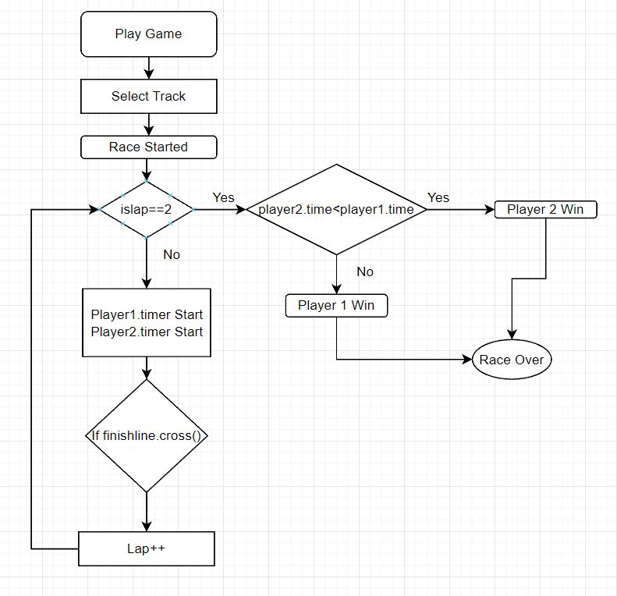

The basic look and feel of Point Break would be futuristic and sleek, with a visual style that blends elements of sci-fi and high-speed racing. The game would feature a polished look with vibrant colors and plenty of visual flair to create an immersive racing experience.

The design pillars for Point Break, which formed the foundation of the game's design areas; High Speed Racing, Futuristic Design, Competitive Multiplayer, Varied Tracks and Environment.

* Gameplay & Mechanics

The gameplay in Point Break would be fast-paced and exhilarating, with a focus on high-speed racing and intense competition. The player's journey in Point Break would be a progression from one track to another, as they compete in a variety of races and challenges to become “the ultimate hover ship racing champion.”

The Mechanics for Point Break includes;

* Hover Ship movement, Upgrades and Customization, Racetracks, and Coop Opponent.

**Physics:** The ship is made to hover at a specific height, keeping gravity in mind. Moreover, the angle of roll is set accurately, so it’s easier for the car to take turns and avoid the railings.

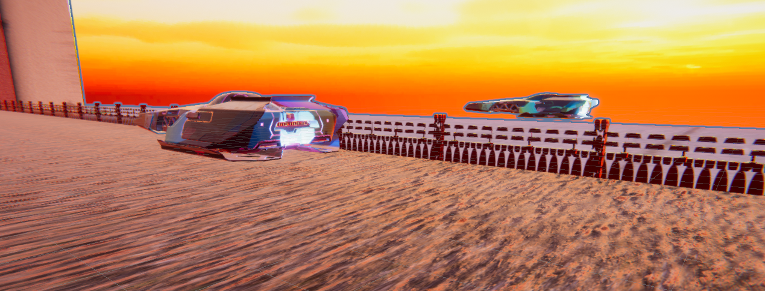

**Movement:** The ship has simple movement. WASD are used for player one while the arrow keys are for the second player.

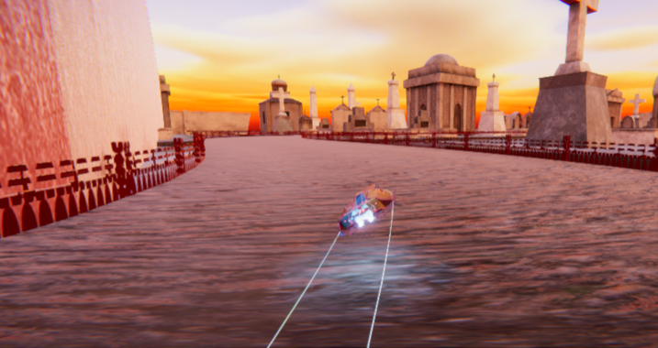

**Objects:** The tracks are made using a unity system called RoadArchitect. It enabled us to create tracks with railings. Furthermore, there are multiple objects on the terrain like buildings, hills, mountains, lakes. These all are added using different prefabs from the internet.

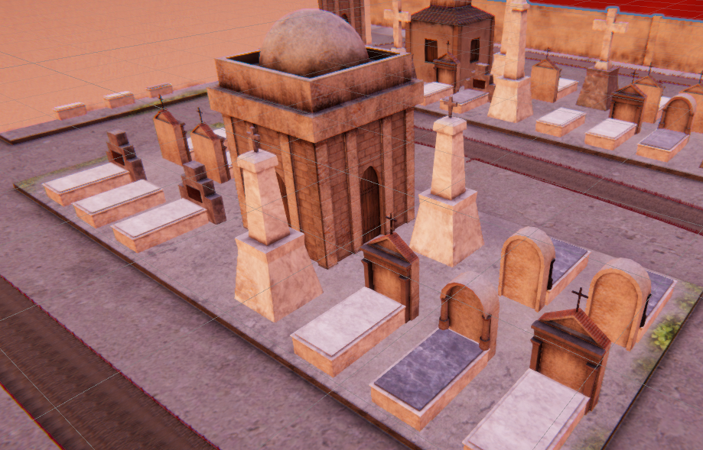

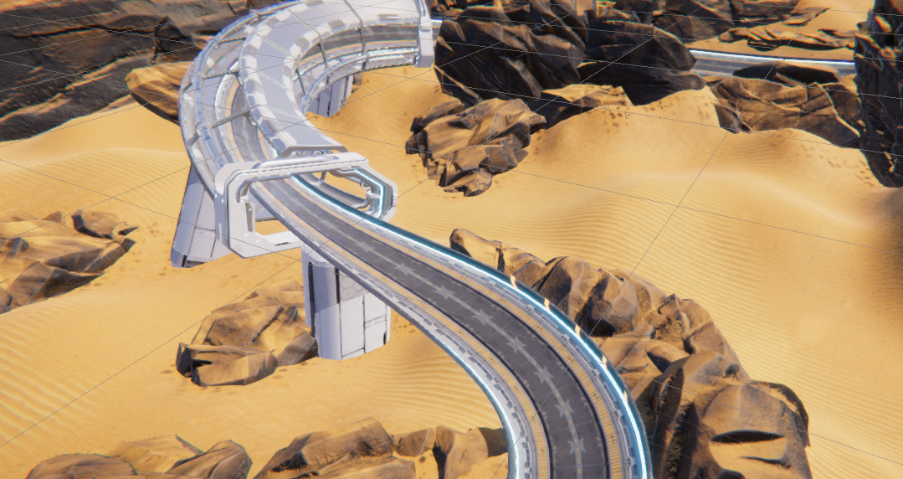

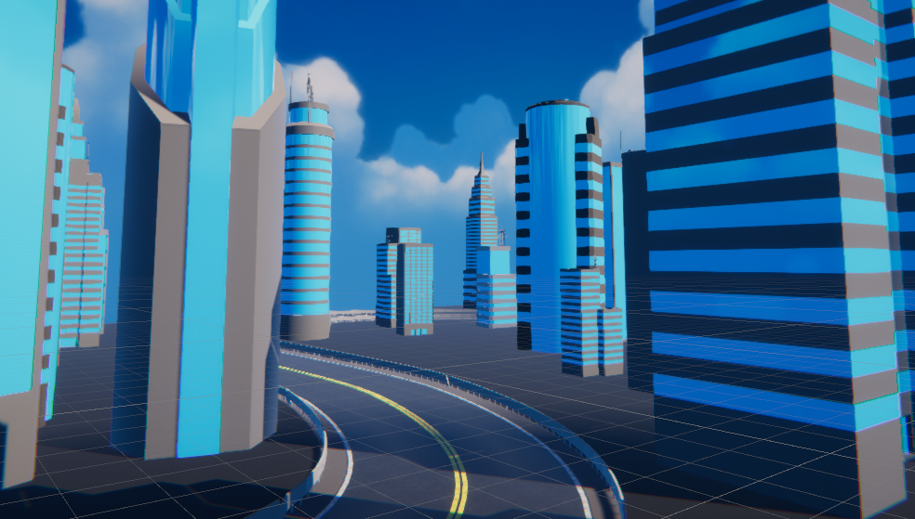

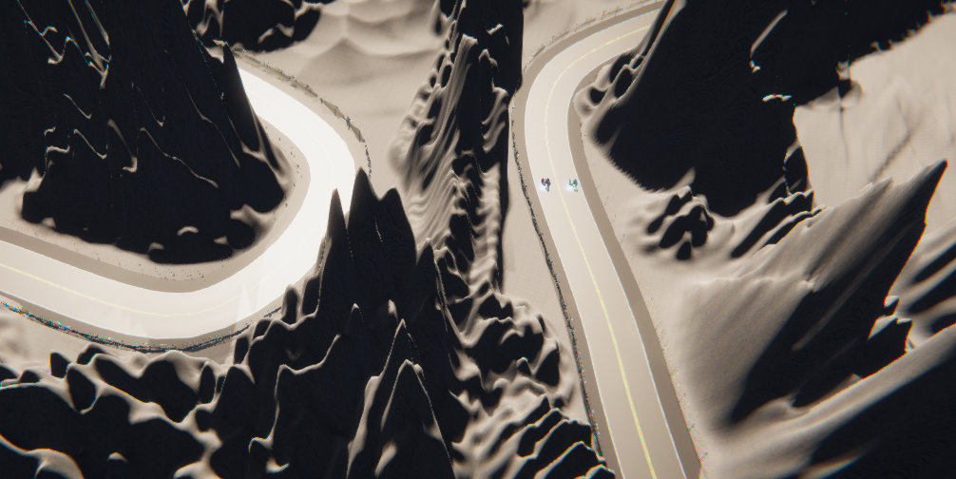

**Actions:** The track is set to ground layer meanwhile railings, buildings, graves, walls are set to wall layer to detect collisions.

One of the cars is set to default layer while the other is set to wall layer so the game detects the collision between both cars.

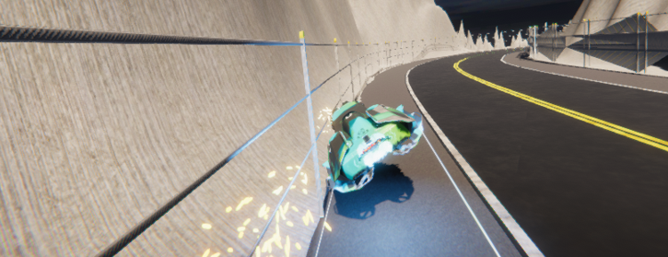

**Screen Switch:** The game starts with the Main Menu and the player is asked to select a lap track. After completing the tracks, the players are taken back to the track list so the players can select the next track to play.

**Game Options:** The game has different setting from setting the sound and audio level to adjusting the brightness of the whole game.

* Story, Setting and Character

In the distant future, Point Break has become the most popular and lucrative sport in the galaxy. Pilots compete in high-speed races, battling for fame, fortune, and the coveted title of racing champion.

Point Break is a mix of futuristic and natural landscapes with elements of decay and danger. It has the following tracks;

**Rocky track**

This track could be set in a desolate, rocky terrain with harsh weather conditions.

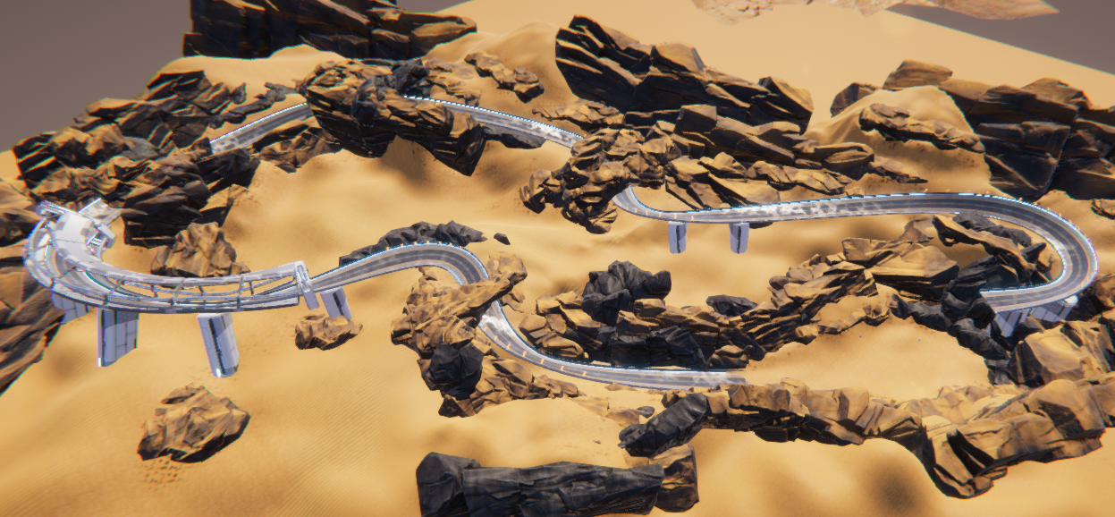

**Mountain track**

This track is set in a remote mountain range with breathtaking views and unpredictable weather conditions.

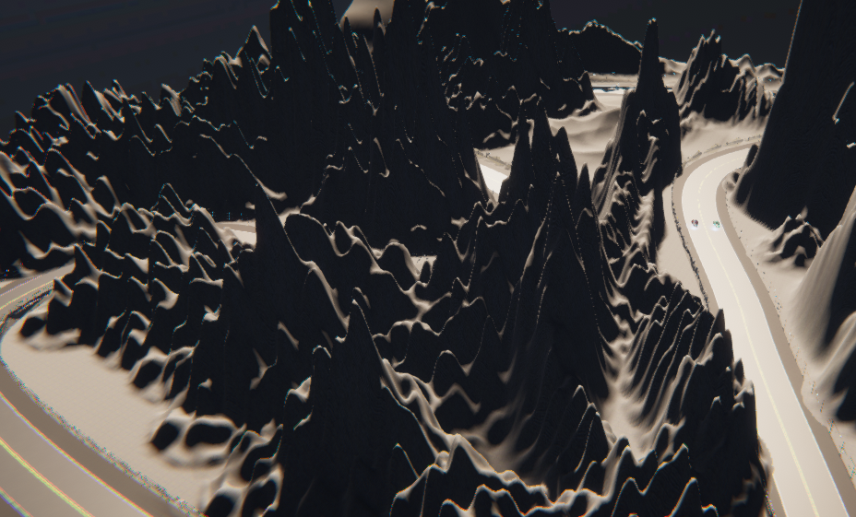

**Futuristic track**

This track takes place in a sleek, high-tech cityscape with neon lights, holographic billboards, and advanced transportation systems.

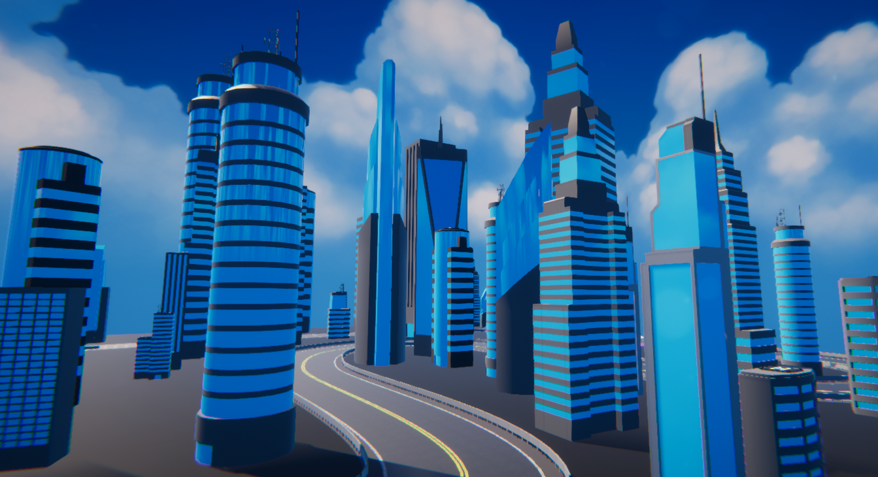

**Graveyard track**

This track could take place in an abandoned graveyard or cemetery with an eerie atmosphere.

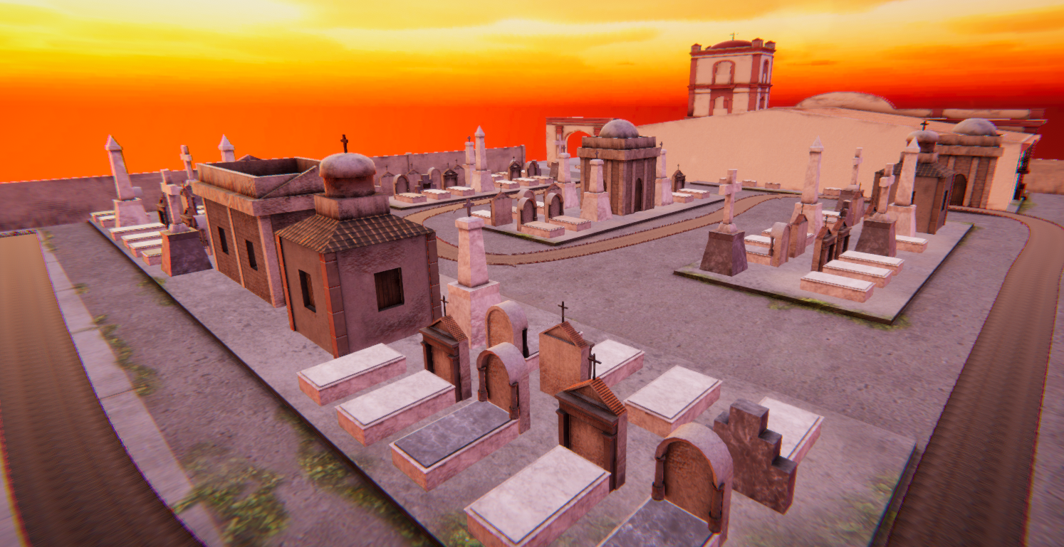

* Interface

The player is presented with a speedo meter, lap track time, their position in the race and the amount of lap covered. The menu has 4 options; The Play which takes the user to tracks, the settings where user can change the set up of the game, The credits which includes the name and roll numbers of the people handling the project and at last the Quit Button.

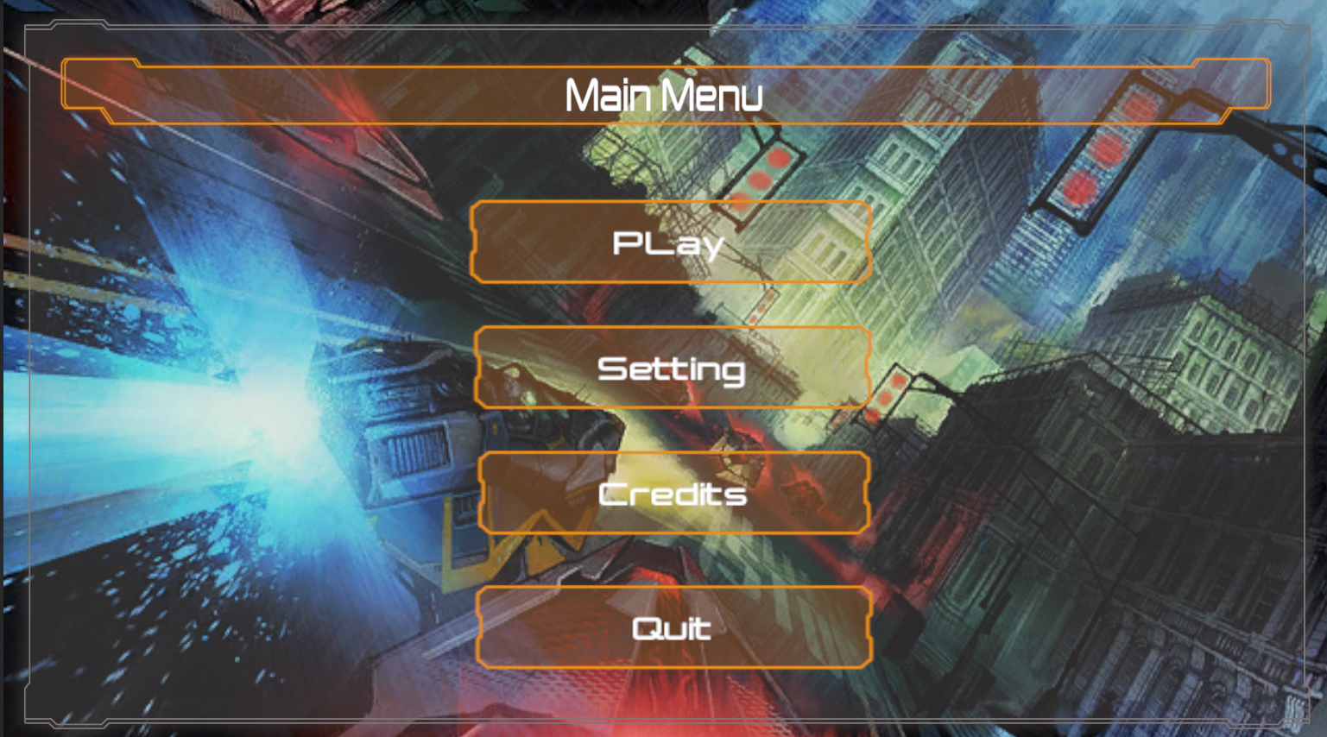

The camera is hooked to the car so that it follows the car throughout the track and positions itself at a specific angle when making a turn.

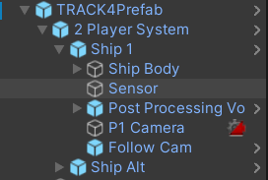

For audio we have used a single Engine Hum voice used when the car accelerates.

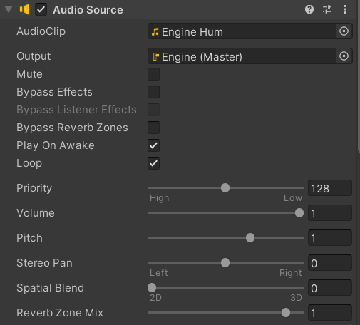

* Coop Mode

Point break uses a coop mode where both the cars are on display all the times. The screen is split into half for both users.

